Mean Shift

Definition
Mean Shift is a non-parametric clustering algorithm that identifies dense regions of data by repeatedly shifting points toward the local mean of neighboring observations.
Unlike K-Means, Mean Shift does not require the number of clusters KK to be specified in advance.

Mean Shift Intuition
Imagine points distributed like:
● ● ●
● ● ● ● ●
● ● ●

● ●
● ● ● ●
● ●
There are two dense regions.
Mean Shift starts from a point and asks:
Where is the center of the nearby data?
Then it moves the point toward that center.
Repeat:
Starting point
↓
Local mean
↓
Move
↓
New local mean
↓
Move
↓
Density maximum

Mean Shift Mathematical Formulation

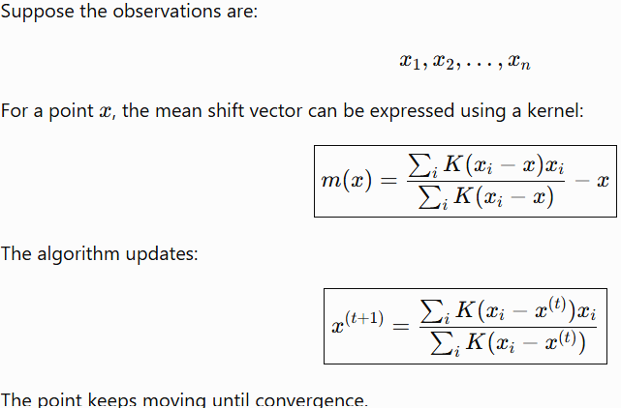

The point keeps moving until convergence.

Uniform Kernel Intuition
A simple version considers only points within a radius h.
The update is:
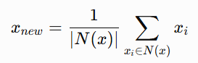
where N(x) is the neighborhood.
Then:
x ← xnew
repeatedly.

Bandwidth

The most important Mean Shift parameter is : h
called the bandwidth.
It determines the neighborhood size.

Small Bandwidth
Small h:
Small neighborhoods
↓
Many density peaks
↓
Many clusters
Potential problem : Over-segmentation

Large Bandwidth
Large h:
Large neighborhoods
↓
Fewer density peaks
↓
Fewer clusters
Potential problem : Under-segmentation

53. Mean Shift Geometric Intuition
Imagine a landscape:
/\ /\
/ \ / \
/ \ / \
__________/ \________/ \____
The data density creates hills.
Mean Shift moves points uphill toward a local density maximum.
Each density maximum becomes a potential cluster center.

Mean Shift and Density Estimation
Mean Shift is closely related to kernel density estimation (KDE).
KDE estimates:
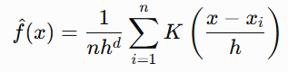
Mean Shift essentially follows the gradient toward modes of this estimated density.
Therefore:
Mean Shift ≈ Mode Seeking

Mean Shift Advantages
- Does not require KK.
- Can discover arbitrary cluster shapes.
- Based on density.
- Naturally finds cluster centers/modes.
- Useful when the number of clusters is unknown.

Mean Shift Limitations
- Computationally expensive for large datasets.
- Bandwidth selection is critical.
- Sensitive to scale.
- Different bandwidths can produce very different results.
- Can perform poorly when cluster densities vary significantly.

When Should You Use Mean Shift?
Choose Mean Shift when:
- You do not know the number of clusters.
- Clusters correspond to density peaks.
- You can select a meaningful bandwidth.
- The dataset is not excessively large.
Examples:
- Image processing
- Object tracking
- Computer vision
- Spatial density analysis

